Standard Operating Procedure (SOP)
Date: 10th December 2021
SOP title: Lynch Syndrome early diagnosis pathway: guidance for the colorectal cancer MDTs within the RM partners cancer alliance
Project lead: Dr Kevin Monahan, Consultant Gastroenterologist, St Mark's Hospital Lynch Syndrome & Family Cancer Clinic
Project managers: Timothy Bill, Programme lead, RM Partners
Author: Laura Monje-Garcia, Nurse Practitioner, St Mark’s Hospital Centre for Familial Intestinal Cancer

Version | Date | Updates Made | Updated by
V-1 | 30.11.2020 | SOP created | LMG
V-1.1 | 01.12.2020 | SOP amended to add 62 day from diagnosis to referral target | LMG, KM
V-1.3 | 25.01.2021 | SOP amended: Timeline table added | LMG
V-1.4 | 01.03.2021 | SOP amended: AB & ZK suggestions added | LMG, KM
V1.5 | 15.03.2021 | SOP sing off by RMP & Pathway group | KM
V2 | 29.10.2021 | SOP updated as per new National Genomic Test Directory and New flowchart added | LMG
V2 | 10.12.2021 | Approved by KM | KM

Objective
This SOP relates to delivery of the early diagnostic pathway, from diagnosis of colorectal cancer to diagnosis of Lynch Syndrome. The guidance is for colorectal cancer MDTs within the RM Partners cancer alliance. It outlines the diagnostic pathway, and individual MDTs responsibilities.

Team Members
- CRC MDT pathway partners (governance through RM Partners, our regional cancer alliance pathway group:
  - St Mark’s Hospital, London North West University NHS Trust
  - Chelsea & Westminster Hospital NHS Foundation Trust
  - Imperial College Healthcare NHS Trust
  - Hillingdon Hospitals NHS Foundation Trust
  - St George’s University Hospitals NHS Foundation Trust
  - Kingston Hospital NHS Foundation Trust
  - Croydon Health Services NHS Trust
  - Epsom & St Helier University Hospitals NHS Trust
- Regional Expert Centres:
  - St Mark's Hospital Lynch Syndrome & Family Cancer Clinic
  - Northwick Park Hospital clinical genetics department (North West Thames)
  - St George’s Hospital clinical genetics department (South West Thames)
  - The Royal Marsden Hospital Cancer Genetics Unit

General Principles
- All newly diagnosed CRC patients who are identified as likely to have Lynch Syndrome should be referred for genetic testing (either locally or specialised genetics centre) within 62 days of CRC diagnosis.
- Each CRC MDT should identify a responsible local lead for the Lynch diagnostic pathway (a ‘Lynch champion’), who may identify specific tasks for others within the MDT.
- Each CRC MDT is responsible for the delivery of the pathway locally. To deliver this pathway each CRC MDT should work with regional genetics expert centres.
- Genetic testing should be performed by clinical genetics centres, or ‘mainstreamed’ by trained clinicians (CRC MDT clinician designated by the national testing directory).
- Each MDT should choose to offer either genetic testing via ‘mainstreaming’ or referring patients to their linked genetics centre. Thus local CRC MDTs should aim to achieve either
  - Timely referral of patients for genetic testing only after completion of IHC +/- methylation testing, or
  - Mainstreaming of genetic testing ‘in-house’
  - The SOP has been mapped to the:
- NICE DG27 guideline (DG27 Molecular testing strategies for Lynch syndrome in people with colorectal cancer, 2017)
- The NHS England handbook: Implementing Lynch syndrome testing and surveillance pathways (2021)
- The National Genomic Testing Directory (2021)

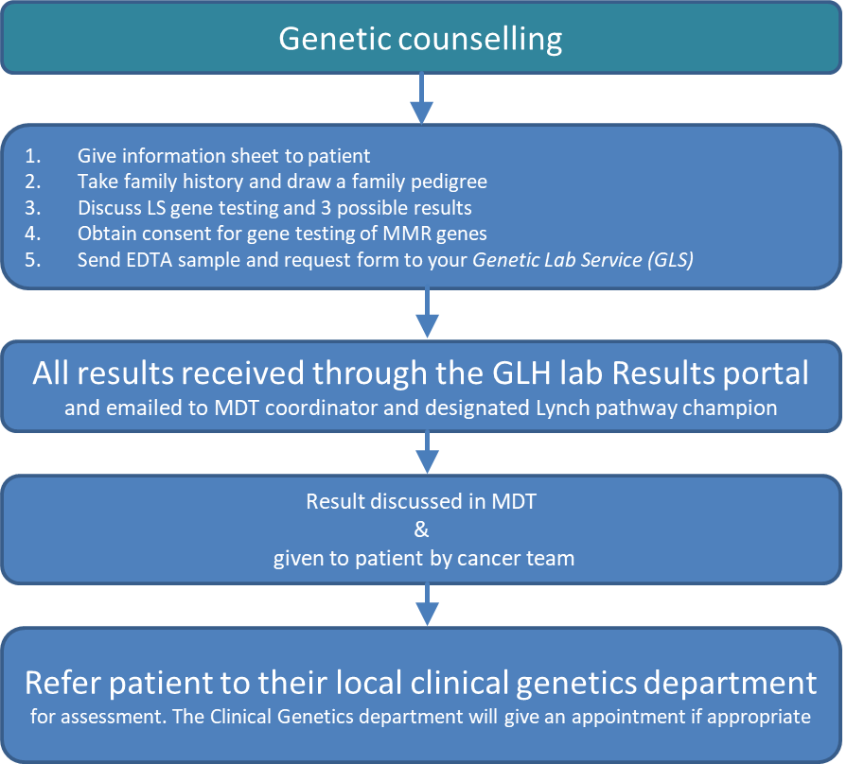
Flowcharts
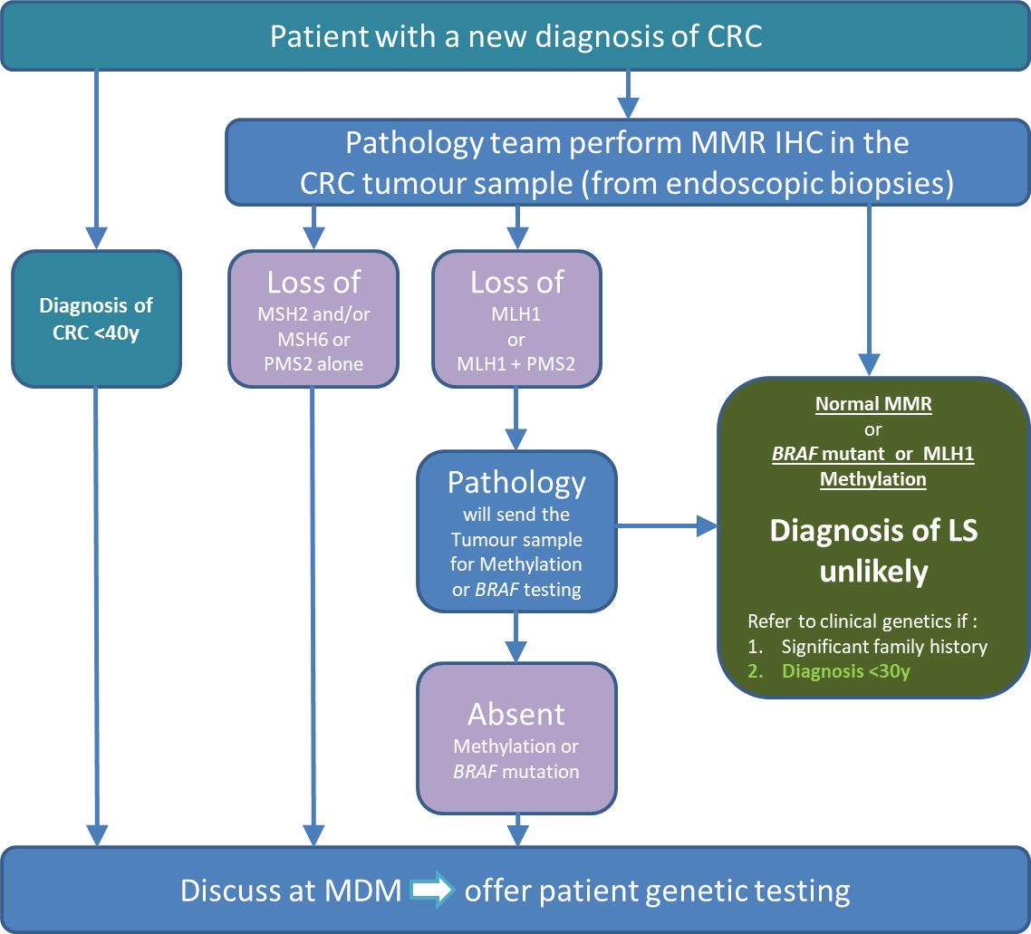

Timeline: 62 days from diagnosis of CRC to referral (timeline explained in Appendix 2)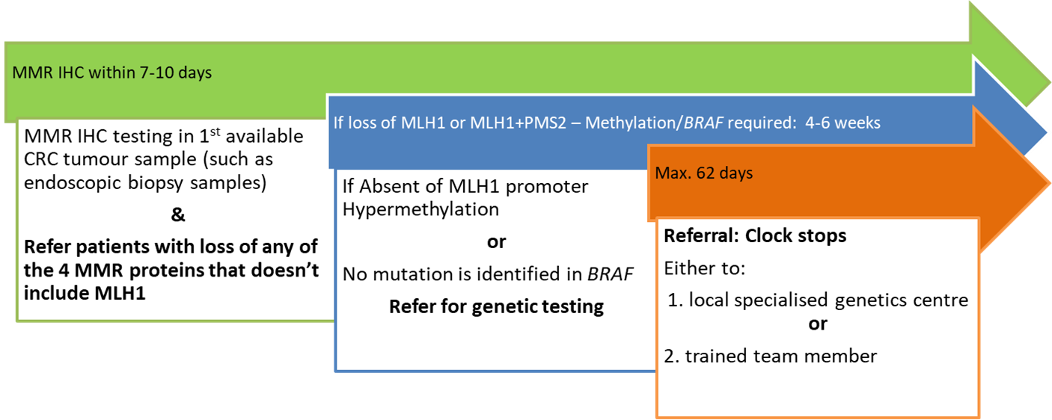

Standard Operating Procedure
Part 1: The tumour testing pathway

- Initial tumour assessment for Lynch Syndrome
- Every patient with a new diagnosis of Colorectal Cancer (CRC) should have their first available tumour sample tested for the expression of the four Mismatch Repair (MMR) proteins done by MMR Immunochemistry (IHC).
  - This result should be available within 7 days of first tumour biopsy to ensure that it can be discussed at the index CRC MDM.
  - IHC should be performed in the first available endoscopic biopsies, but may be performed in surgical resection specimens where endoscopic biopsies were not available/previously tested.
  - At least 60% of patients should have testing performed on colonoscopic biopsies,
  - 100% of patients should have testing where tumour tissue is available.
- MMR IHC results should be discussed and documented during the MDT meeting.
- All patients who are diagnosed with CRC under age 40 years are eligible for genetic testing for Lynch syndrome. This can be performed in your local ‘mainstreaming’ service, if you have one set-up. However, consider referral to your local clinical genetics or expert centre if there is a suspicion of a non-Lynch syndrome CRC (i.e. Polyposis syndrome).

- Action following MMR IHC results & referral for genetic counselling
- MMR IHC assesses the expression of the four MMR proteins: MLH1, MSH2, MSH6, and PMS2. If there is a loss of any of these proteins, then further diagnostic tests are indicated.
- All patients with a tumour sample with loss of MMR protein expression but without loss of MLH1 should now be referred for genetic counselling and testing. This action should be documented in the MDM outcome. Go to section d)

- Further testing for tumour samples with loss of expression of MLH1 or loss of MLH1+PMS2 on MMR IHC
- Tumour samples with loss of MLH1 expression will require further testing. This can be either MLH1 promoter Hypermethylation or BRAF mutation testing of the tumour. Only one of these tests is necessary before referral for genetic testing.
  - Methylation testing of MLH1 should be ‘reflex’ requested by the CRC MDT pathologist who reports the IHC MMR.
  - The MDT should discuss and document the MMR IHC result and choose either MLH1 promoter Hypermethylation as a default test, or BRAF testing as an alternative. If the patient is due to have systemic therapy then BRAF testing should be requested as part of a somatic panel as per NICE Colorectal Cancer guidelines NG151.
- Once the result is available, the MDT should arrange further MDM discussion.
1) If the tumour sample is absent of MLH1 promoter Hypermethylation or no mutation is identified in BRAF (also called BRAF wild type), the patient may have Lynch Syndrome and should immediately be referred for genetic testing.
2) If the tumour sample shows that there is a mutation in BRAF, or MLH1 promoter methylation is identified, then it is unlikely that the patient has Lynch syndrome.
Patients without evidence of Lynch syndrome on tumour testing, but who are diagnosed with CRC under age 40 years, or those with a high risk family history of CRC, may also be referred to regional expert centres for further genetic assessment.

- Referral for genetic counselling
- For eligible patients, the MDT should refer the patient to their local clinical genetics centre, or ‘mainstreamed’ locally by a trained cancer MDT clinician.
- A referral proforma letter should be completed during the MDM, ready to be processed and posted immediately. An example of this fast-track MDM referral letter can be found in appendix 1.
- Eligible patients should be informed by an MDT member that they will receive a genetic assessment.

Part 2: Mainstreaming: Genetic counselling & testing performed by members of local CRC MDTs

- Before offering ‘in-house’ mainstreaming, a member of the local CRC MDT should have completed the online training for mainstreaming with certification, and associated practical workshops.
- The MDT clinician who performed the genetic counselling should contact the patient and give them their genetic result.
- The MDT clinician should make surveillance recommendations for the patient, and for their first-degree family members in line with BSG guidelines.
- Then patients should be referred to their local clinical genetics centre for virtual review and further management
  - 1) Pathogenic variant identified: the regional expert centre will offer a consultation.
  - 2) Variant of uncertain significance (VUS) identified, or no pathogenic variant was found, the expert centre will choose whether:
    - to perform a virtual review of the case to assess if further tumour testing or segregation studies could be offered.
    - or to offer a consultation to discuss the implication of the results for the patient and their family members
- Results and surveillance recommendations may be discussed in regional specialised cancer genetics MDT meeting, e.g. St Mark’s virtual (Microsoft Teams) Hereditary MDM Tuesdays at 9am. If you would like to attend this meeting or present a case, you can email LNWH-tr.SMCFIC@nhs.net for the Microsoft Teams access details.

- References

NICE DG27 guidance ‘Molecular testing strategies for Lynch syndrome in people with colorectal cancer’

The NHS England handbook: Implementing Lynch syndrome testing and surveillance pathways (2021)
Lynch syndrome quality improvement project

Lynch syndrome training website

Lynch syndrome training supporting documents

Lynch syndrome patient information website

National Genomic Test directory October 2021

Lynch syndrome patient information website

Appendix 1
Patient label – affix here
Hospital’s Header Here
Dr GP
Address

Date: ……….

Dear Dr …,
Mr/Mrs (DOB: ; Hospital Number) has been discussed in our colorectal cancer MDT. According to current NICE guidelines and the guidelines from British Society of Gastroenterology (BCG) for hereditary colorectal cancer, Patient name requires referral to further discuss his family history of cancer, genetic assessment, and possible genetic testing for Lynch Syndrome for the following reason:
IHC result shows loss of …………………………………. …… ☐
If loss of MLH1, further testing performed ………….....……. ☐
Result:
-Absent MLH1 Hypermethylation…………………… ☐
Or
-Absent of BRAF mutation ……..……………………. ☐
Diagnosis of Colorectal Cancer < 40 years of age……………. ☐
As this is a new referral in the symptomatic service, the request is required to come from the General Practitioner. However, in order to expedite the patient to symptomatic service we have made this referral on your behalf. If you have any objections please let us know as soon as possible.
The patient has been advised of this referral. If you have any questions, you can contact the Family Cancer Clinic on 020 8453 2656, or by email: LNWH-tr.SMCFIC@nhs.net
Kind regards,

Referrer signature

cc.
Patient

cc. Trained member of the MDM team or specialised genetics centre
via email to avoid delay …………..@nhs.net

Checklist
- Attach histopathology reports
- Attach minutes from cancer MDT meeting
- Call and inform patient they will receive an appointment for genetic referral

Appendix 2
Timeline explained

The testing pathway should be completed within 62 days from the date of diagnosis of CRC to the date of referral for genetic testing/mainstreamed testing
- MMR IHC testing should be completed by the local pathology department within 7-10 days in the first available tumour sample available, such as endoscopic biopsy samples.
- If there is a loss of any of the 4 MMR proteins that doesn’t include MLH1, the patients should be referred for genetic testing and the clock will stop at this point. If this takes longer than 62 days, this should be discussed within the regional specialist team to identify possible solutions.
- If there is loss of MLH1, further tumour testing will be required and should be arranged by local CRC MDTs. This will be either BRAF or MLH1 promoter Hypermethylation test. Either of these tests should be completed within 4-6 weeks to meet the 62 day target. If this pathway (from diagnosis to referral to genetic testing) takes longer than 62 days, this should be discussed within the team to find possible solutions.
- It’s recommended that each MDT perform regular audits to assess compliance with the 62 days Lynch syndrome early diagnosis pathway.

