Standard Operating Procedure (SOP)
Date: 10th December 2021
SOP title: Lynch Syndrome early diagnosis pathway: guidance for the gynaecological cancer MDTs
Project leads: Dr Kevin Monahan, Consultant Gastroenterologist, St Mark's Hospital Lynch Syndrome & Family Cancer Clinic
Project managers: Timothy Bill, Programme lead, RM Partners
Author: Laura Monje-Garcia, Nurse Practitioner, St Mark’s Hospital Centre for Familial Intestinal Cancer

Version | Date | Updates Made | Updated by
V-1 | 09.07.2021 | SOP created | LMG
V-1.01 | 22.07.2021 | Flowchart updated | LMG
V-2 | 23.07.2021 | SOP updated | KM
V-2.02 | 29.10.2021 | Flowchart updated | LMG
V-2.02 | 10.12.2021 | Approved by KM | KM

Objective
This SOP relates to delivery of the early diagnostic pathway, from diagnosis of endometrial cancer to diagnosis of Lynch Syndrome. The guidance is for gynaecological cancer MDTs. It outlines the diagnostic pathway, and individual MDTs responsibilities.

General Principles
- All newly diagnosed endometrial cancer patients who are identified as likely to have Lynch Syndrome should be referred for genetic testing (either locally or specialised genetics centre)
- Each MDT should identify a responsible local lead for the Lynch diagnostic pathway (a ‘Lynch champion’), who may identify specific tasks for others within the MDT.
- Each MDT is responsible for the delivery of the pathway locally. To deliver this pathway each MDT should work with regional genetics expert centres.
- Genetic testing should be performed by clinical genetics centres, or ‘mainstreamed’ by trained clinicians (MDT clinician designated by the national testing directory).
- Each MDT should choose to offer either genetic testing via ‘mainstreaming’ or referring patients to their linked genetics centre. Thus local MDTs should aim to achieve either
  - Timely referral of patients for genetic testing only after completion of IHC +/- methylation testing, or
  - Mainstreaming of genetic testing ‘in-house’

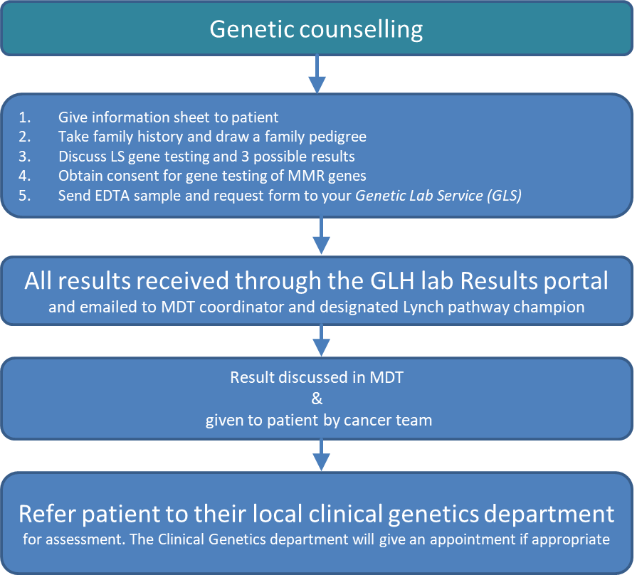
Flowcharts
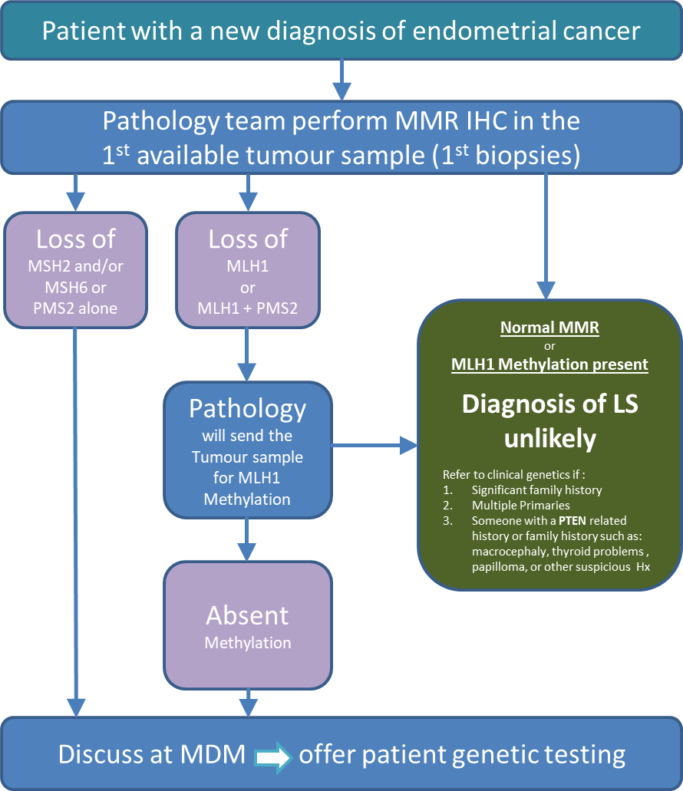

The SOP has been mapped to the:
- NICE DG42 guideline (DG42 Testing strategies for Lynch syndrome in people with endometrial cancer, 2020)
- The NHS England handbook for cancer alliances (2021)
- The National Genomic Test Directory (2021)

Standard Operating Procedure
Part 1: The tumour testing pathway

- Initial tumour assessment for Lynch Syndrome
- Every patient with a new diagnosis of endometrial cancer should have their first available tumour sample tested for the expression of the four Mismatch Repair (MMR) proteins done by MMR Immunochemistry (IHC).
  - IHC should be performed in the first available biopsies, but may be performed in surgical resection specimens where biopsies were not available/previously tested.
- MMR IHC results should be discussed and documented during the MDT meeting.

- Action following MMR IHC results & referral for genetic counselling
- MMR IHC assesses the expression of the four MMR proteins: MLH1, MSH2, MSH6, and PMS2. If there is a loss of any of these proteins, further diagnostic tests are indicated.
- All patients with a tumour sample with loss of MMR protein expression but without loss of MLH1 should now be referred for genetic counselling and testing. This action should be documented in the MDM outcome. Go to section d)

- Further testing for tumour samples with loss of expression of MLH1 or loss of MLH1+PMS2 on MMR IHC
- Tumour samples with loss of MLH1 expression will require further testing with MLH1 promoter Hypermethylation.
  - Methylation testing of MLH1 should be ‘reflex’ arranged by the MDT pathologist who reports the IHC MMR.
- Once the result is available, the MDT should arrange further MDM discussion.
1) If the tumour sample is absent of MLH1 promoter Hypermethylation the patient may have Lynch Syndrome and should immediately be referred for genetic testing.
2) If the tumour sample shows that MLH1 promoter methylation is identified, then it is unlikely that the patient has Lynch syndrome (pathway stops).
- Patients without evidence of Lynch syndrome on tumour testing, but who are diagnosed with endometrial cancer with a high risk family history of cancer or, multiple primaries, or with a PTEN related history or family history (such as macrocephaly, thyroid problems, papilloma, etc.) may also be referred to regional expert centres for further genetic assessment.

- Referral for genetic counselling
- For eligible patients, the MDT should refer the patient to their local clinical genetics centre, or ’mainstreamed’ locally by a trained cancer MDT clinician.
- A referral proforma letter should be completed during the MDM, ready to be processed and posted immediately. (An example of this fast-track MDM referral letter can be found in appendix 1.
- Eligible patients should be informed by an MDT member that they will receive a genetic assessment

Part 2: Mainstreaming: Genetic counselling & testing performed by members of local MDTs

- Before offering ‘in-house’ mainstreaming, a member of the local MDT should have completed the online training for mainstreaming with certification, and additional practical workshops.
- The MDT clinician who performed the genetic counselling should contact the patient and give them their genetic result.
- The MDT clinician should make surveillance recommendations for the patient, and for their first-degree family members in line with BSG guidelines.
- Then patients should be referred to their local clinical genetics centre for virtual review and further management
  - 1) Pathogenic variant identified: the regional expert centre will offer a consultation.
  - 2) Variant of uncertain significance (VUS) identified, or no pathogenic variant was found, the expert centre will choose whether:
    - to perform a virtual review of the case to assess if further tumour testing or segregation studies could be offered.
    - or to offer a consultation to discuss the implication of the results for the patient and their family members
- Results and surveillance recommendations may be discussed in regional specialised cancer genetics MDT meeting, e.g. St Mark’s virtual (Microsoft Teams) Hereditary MDM Tuesdays at 9am. If you would like to attend this meeting or present a case, you can email LNWH-tr.SMCFIC@nhs.net for the Microsoft Teams access details.

- Resources & References
NICE DG42 guidance ‘Testing strategies for Lynch syndrome in people with endometrial cancer’

The NHS England handbook: Implementing Lynch syndrome testing and surveillance pathways (2021)
Lynch syndrome quality improvement project

Lynch syndrome training website

Lynch syndrome training supporting documents

The National Genomic Test Directory (2021)

Lynch syndrome patient information website

Appendix 1
Patient label – affix here
Hospital’s Header Here
Dr GP
Address

Date: ……….

Dear Dr …,
Mr/Mrs (DOB: ; Hospital Number) has been discussed in our colorectal cancer MDT. According to current NICE guidelines and the guidelines from British Society of Gastroenterology (BCG) for hereditary colorectal cancer, Patient name requires referral to further discuss his family history of cancer, genetic assessment, and possible genetic testing for Lynch Syndrome for the following reason:
IHC result shows loss of …………………………………. …… ☐
If loss of MLH1, further testing performed ………….....……. ☐
Result:
-Absent MLH1 Hypermethylation…………………… ☐

As this is a new referral in the symptomatic service, the request is required to come from the General Practitioner. However, in order to expedite the patient to symptomatic service we have made this referral on your behalf. If you have any objections please let us know as soon as possible.
The patient has been advised of this referral. If you have any questions, you can contact the Family Cancer Clinic on 020 8453 2656, or by email: LNWH-tr.SMCFIC@nhs.net
Kind regards,

Referrer signature

cc.
Patient

cc. Trained member of the MDM team or Specialised genetics centre
via email to avoid delay …………..@nhs.net

Checklist
- Attach histopathology reports
- Attach minutes from cancer MDT meeting
- Call and inform patient they will receive an appointment for genetic referral

