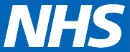
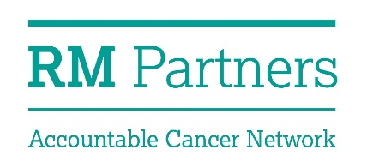

Application Form - Member
RM Partners Patient Advisory Group

Please return to rmpartners.info@nhs.net by midday on 8 May 2017.

Name
Address
Email Address
Telephone Number
What appeals to you about participating in the RM Partners Patient Advisory Group. (max 200 words)
Are you a resident of, or a servicer user in West London?

Have you had an experience of cancer services, either as a patient, carer, volunteer or staff member?

Why do you think it is important for people who use health services and NHS staff to work together to improve things?
How do you think you could contribute to the advisory group?

Please describe your skills and experience or contribution to change. (max 800 words)
Do you have any additional support needs that you would like help with to enable you to participate in this work? Please give details.

